**EnCampus Portal Training Guiding**

**Links to the EnCampus Portal can be found in a number of places – be sure to bookmark the link for easy access!**

[**https://schedule.sju.edu**](https://schedule.sju.edu)

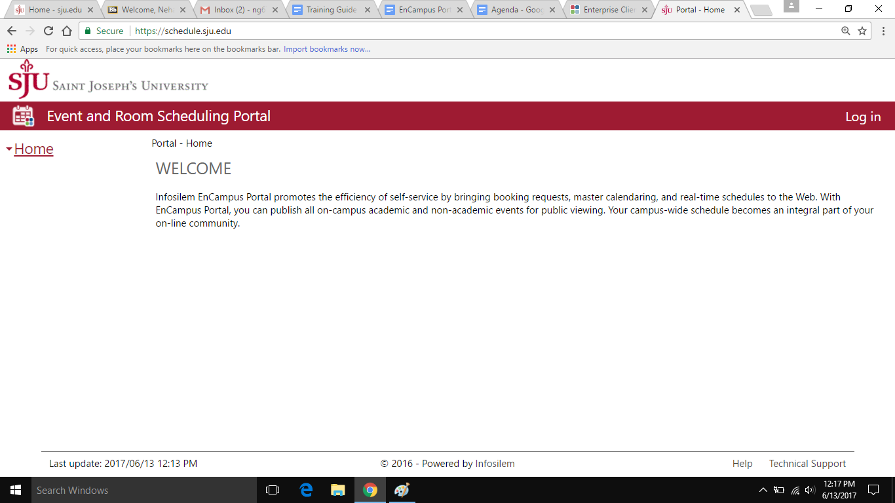

**Home Page**

**Logging in**

Users will log in to the [EnCampus Portal](https://schedule.sju.edu) with their SJU username and password.



**Home Page**

After logging in, you will be taken to the Portal Home Page which contains some general information as well as a table indicating the dates on which a user may begin to place requests during the specified date/time ranges.

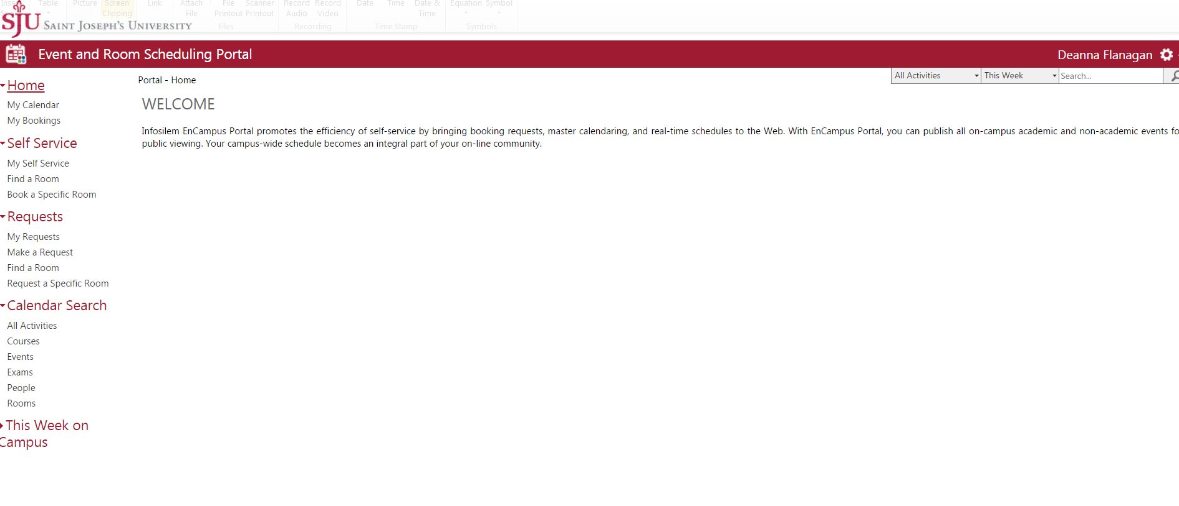

**Things to Note When Requesting Academic Space**

* Reservation requests are processed during normal business hours (Monday through Friday, 9am-5pm)
* Reservation requests are processed within the order they are received
* If the room you are seeking is not available, the Office of the Registrar will attempt to reserve a classroom/lab specific to your needs.
* You will receive an email from the Office of the Registrar if your request is cancelled or updated.
* The Registrar’s Office can process Spring/Fall free-period reservations at anytime throughout the Academic Year. All other reservations will be processed **AFTER** the Add/Drop period for that particular Semester.

The following schedule indicates the date’s reservation requests will be begin to be accepted for each period within a semester:

|  |  |  |  |
| --- | --- | --- | --- |
| **Term** | **Date Range** | **Reservable Times** | **Date Reservations will begin to be processed** |
| *Summer 2017* | May 8, 2017 to August 26, 2017 | Every Day 7am-12am | May 30, 2017 |
| *Fall 2017* | August 28, 2017  to December 11,2017 | Every Day 7am-12am  Reading Day 12/12/17 7am-12am  *Reservations are not permitted During Final Exam Week* | September 05, 2017 |

**Things to note when requesting Non-Academic Space**

* Reservation requests are processed during normal business hours.
* Reservation requests are processed in the order in which they are received
* If the room you are seeking is not available, the Special Events Office will attempt to reserve a room to your specifications and needs.
* Please supply as much information as possible, i.e. room set up, catering needs, technical needs, number of attendees in the “Other

Information” section of the request page.

the request template to better facilitate your request and room search.

* For space request in Athletics Facilities, Campus Recreation, Bluett Theatre and Chapel please contact those departments directly.

**Make a Request**

**MAKE A REQUEST:** Allows users to select the location and time preference without specifying a specific room . The scheduler will allocate the room pertaining to your preferences as available.

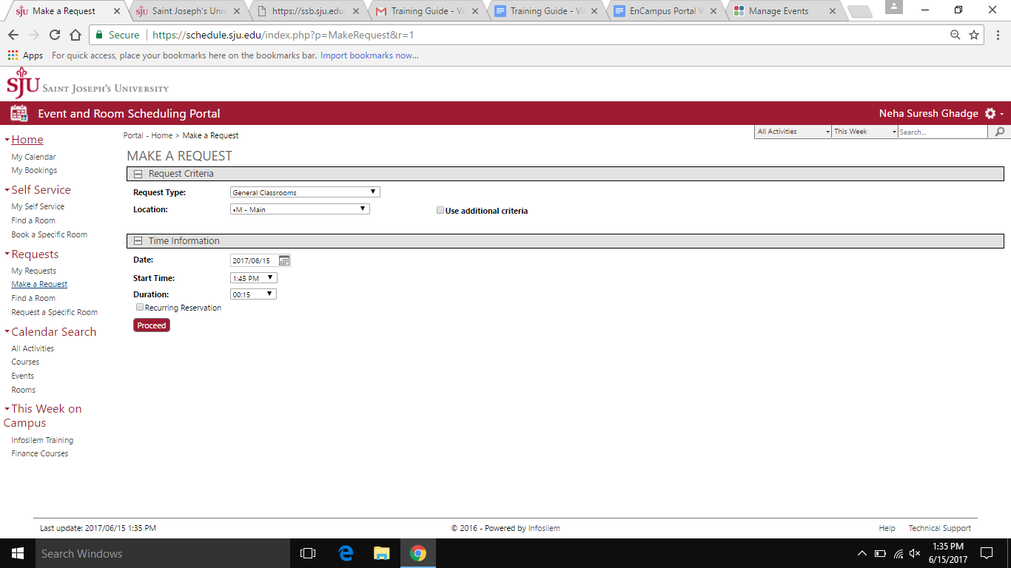

## 

## 

## 

## 

## Find a Room

**FIND A ROOM:** This is used to find an available room when a specific room is not required

* If you want to specify a particular building, select that building from the **Location** drop down box.
* If you want to specify types of room layouts, types of furniture, or a minimum room capacity, check the box that says **Use additional criteria**.

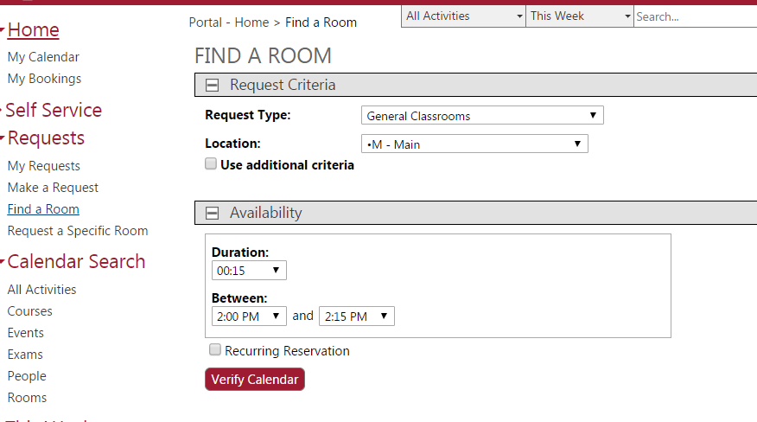

## 

## 

## 

## 

## 

## 

## 

## 

## 

## Request a Specific Room

**REQUEST A SPECIFIC ROOM:** This is used to request a specific room . You can search that room for different days and times to schedule your event, but you need to have a specific room in mind when using this section

* Select the “ Meeting and Event Space” room the Request Type drop down box
* Select the building from the **Location** drop down box
* If you want to specify types of room layouts, types of furniture, or a minimum room capacity, check the box that says **Use additional criteria.**
* Click on the specific room in the list that you would like to request. The line will be highlighted in blue when you have selected it.

## 

## 

## Checking availability

Select a Duration of reservation (include any setup/teardown time needed), and start and end time the Between boxes.

1. Click **Verify Calendar** button
2. Click a date on the calendar to view availability.
3. If available, the start time can be seen and please click on “ Request”.

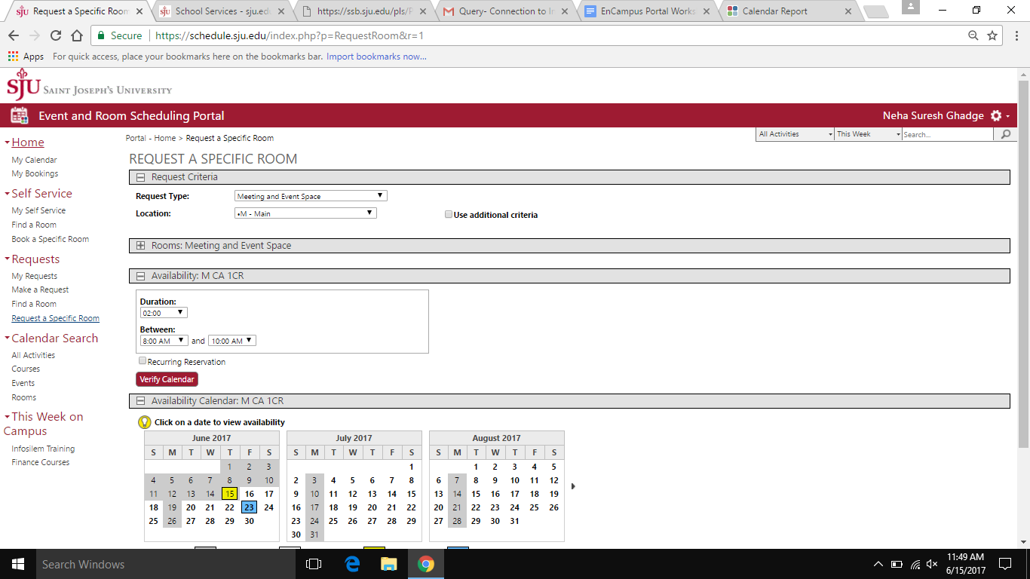

**Request Confirmation:**

Once you submit request button, you will be asked to fill the following questions:

* 1. Number of people attending, additional time requirements, additional room requirements, event details.
  2. Press the Submit Button
  3. Request for the specific room will be sent to Special Events Office.
  4. Once approved, the mail will be received by the requestor from the Special Events Office.

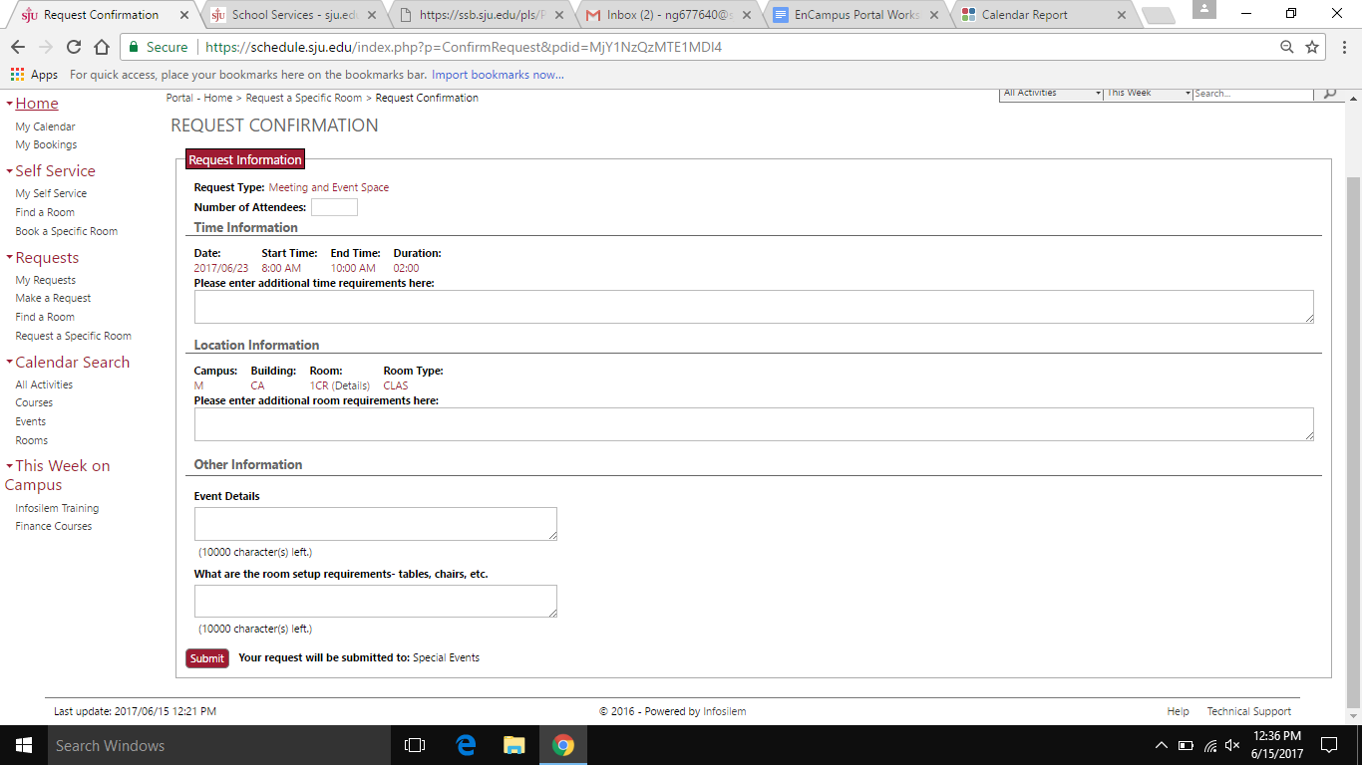

**Make a Recurring Request**

**Make a Recurring Request**

1. Select a beginning and ending date for the recurring reservation in the **From/To** boxes, **Duration** of reservation (include any setup/teardown time needed), and start and end time the **Between** boxes.
2. Click **Set Recurrence Options** button.
3. Set the recurrence options desired and press the **Verify Availability** button.
4. Click **on a row to select a room**
5. Once you click on the row you will be prompted to fill out more information
   1. N**umber of people attending**, **additional time requirements**, **additional room requirements**
   2. Press the **Submit** button

**Tip: If you select a date that already has a reservation in the room you want but you need to schedule this room for more than one date, the following tip will help you proceed with your future bookings:**

***You will need to check the calendar to verify availability of the room and date desired. You will need to note your conflicting dates. Once you have noted all conflicting dates, you will be able to select “ignore” for those specific dates.***

**SELF Service**

**SELF-SERVICE** is currently only available for Library Study Rooms - Allows authorized users to reserve rooms through the Self-Service feature of the Portal. No further approval is required, and reservation is finalized immediately.

## Find a Room vs. Book a Specific Room

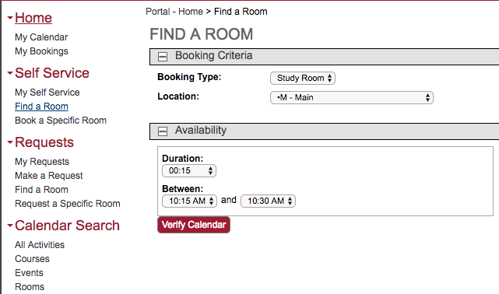

1. To book any study room in the Library use “**Find a Room**”
2. Select 02:00 or less in the **Duration** field (rooms are bookable up to 2 hours)
3. Select the start time for your reservation (enter widest acceptable start/end  
    range to see all available rooms)
4. Choose “Verify Calendar”
5. Choose a date within the next 2-week period
6. Select an available room from the list
7. Choose “Proceed” at the message prompt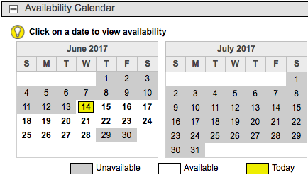
8. Choose “Confirm” at the next screen to finalize your reservation
9. You will receive an email confirmation from infosilem@sju.edu

You can forward this confirmation to other members of your group to let them know the date/time and location of your study meeting

To cancel your reservation go to “My Self Service”

You may make up to three Study Room reservations per week. Please cancel your booking prior to the start time if your group cannot attend. Library staff cannot modify or cancel a reservation on your behalf.

**Calendar Search**

## All Activities

This tool can be used to search for a specific course or event (by reservation or course name, building, time, etc.) or simply to show all activities in a given time frame.

**Courses**

This tool can be used to search for a specific course (by course number, building, time, etc.) or simply show all courses during a given time frame. Do not enter a search string if you want to see all courses.

## Events

This tool can be used to search for a specific event (by reservation name, building, time, etc.) or simply to show all events during a given time frame.

## Rooms

This tool allows you to view a list view or calendar view of all rooms, or only rooms that meet your search criteria. You can also click the Details link on the right to see the image of the room (*coming soon*) and details about capacity and seating arrangement.

**Please email** [**Schedule@SJU.edu**](mailto:Schedule@SJU.edu) **for any questions and concerns.**